RP Fineline 70 (RP-ISO-FINELINE) – thermal insulated
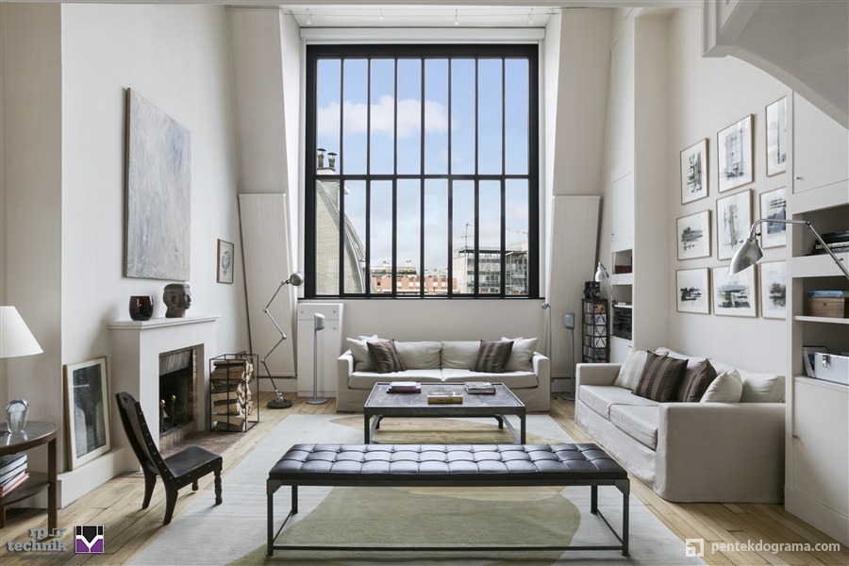
Windows made of zinc coated galvanized steel profiles
This technical specification includes production, shipment and assembly of thermal insulated and glazed windows.
The system consists of steel profiles shaped by roll forming method. The raw material that code is 1.0244 is steel strip.
Following the definition of S280GD + Z 130-B-O according to EN10346, it is coated with zinc-magnesium in immersion baths. The minimum coverage on both sides is 130 g / m2.
Surface quality İs B (improved with cold roll forming) and the surface preparation is O (oiled) class.
Glazing beads are profiles made of extruded aluminum. Aluminum alloy: EN AW 6060 (status: T66 according to EN573-3, EN 755-2).
The following conditions must be provided.
- The case base width is 70 mm, the vent base width is 70 mm and it is overlapped. Hidden vent application is possible.
- Profile construction has a continuous heat bridge plane.
- The distance of the thermal bridge bead to the outer shell of the profile is minimum 10 mm.
- Countour glazing beads can be used.
- Wet and Dry Glazing techniques are possible.
- Up to 34 mm, glasses connect to the heat bridge nail. (Metal holding elements that are attached to the heat bridge at points cannot be used for glass beads, as they will create heat transfer).
- For glasses thicker than 34 mm, beads are clipped to the holding elements placed in the profile channel.
- There is an uninterrupted EPDM gasket on the outside.
- There is a single piece, continuous EPDM gasket on the inside.
- The inner surface of the glass beads stays inside the profile surface.
- The system is tested according to EN14351-1 standard.
- The system has a double seal plane.
- Gaskets connect to the steel profiles with reinforcements.
Main Profiles / Base Width
- The basic depth of frame and muntin bar profiles is 70 mm.
- Vent profile depth is 70 mm.
- The vent profile is pulled in 8 mm (overlaid detail).
- Rain profile can be used in addition.
Main Profiles / Visible Height
- Frame is 25 mm high inside.
- Outside face of the frame could have 25/40/55 mm height.
- The muntin bar is 40 mm high inside.
- The vent is 25 mm high inside. (except beads)
- Vent is 25 mm high (20 mm visible) outside.
- Glasses with a thickness of 23 - 52 mm can be used with standard beads of different sizes, and glasses with a thickness of 23 - 47 mm can be used with contour beads.
Main Profiles / Sections
- Profiles have a wall thickness of 1.5 mm. The thickness increases to 3 mm in folded places.
- Chamfers on the profiles are designed for gaskets, glass beads, hardware and extra profile connections.
Main Profiles / Heat Bridge
- The thermal insulation bridge with special geometry is made of 25% glass fiber reinforced polyamide 6.6.
- The thermal insulation bridge is fixed to the inner-outer steel shells with transverse and longitudinal reinforcements.

Opening Types
- Various opening types such as double axis, single axis, top-hinged opening outwards, bottom-hinged opening inside, double vent opening inside are available.
Corner Connection by Welding
- Inner and outer surfaces are joined by the gas welding method.
- The welding seam is cleaned following the HANDBOOK.
Face Preparation and Coating
- Painting processes are started after cleaning the welding seams.
- It is coated with powder or wet paint technique as desired in the project.
- The preparation is done carefully so that the surface can be cleaned and the paint can adhere. After phosphating, paint with or without primer is applied in a thickness appropriate to the project needs.
Glazing
- Covered glass drainage system is available. Conforms to the glass manufacturers' guidelines.
- Gaskets are used inside and outside. Gasket that stays on the outside is located on a special champher.
- Injection gaskets are used in the corners. The gasket that continues uninterrupted on the inside unites in the upper middle of the glass.
- The geometry of the gasket is determined depending on the glass selection and the pressure required on the glass.
- The wedge is done following the recommendation of glass manufacturers.
Hardware
- The hardware defined by the system manufacturer is used. Selection depends on the desired function and vent weight.
Assembly
- On-site transports are made carefully so that the joinery is not damaged.
- Anchoring alternative is chosen according to the wall type.
- For water and vapor insulation, vapor barrier on the inside and moisture protection elements on the outside are used in accordance with the HANDBOOK recommendations.

