EI 30 CLASS FIRE RATED GLAZED DOORS AND WALL PARTITION
(FIRE RATED GLASS DOOR) TECHNICAL SPECIFICATIONS
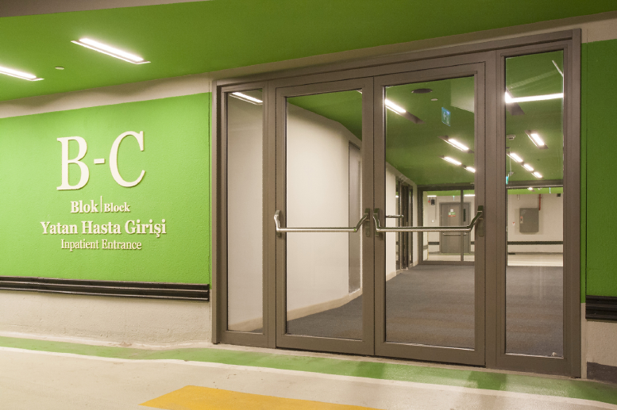
FIRE RATED JOINERY:
Fire-rated joineries are designed, manufactured, tested and certified by the system manufacturer. The manufacturer or an authorized company produces and sells fire-rated joineries following the manufacturer’s production instructions.

1. MATERIAL
1.1. Joinery (Frame)

- Profiles, must be made of steel sheet material with a minimum wall thickness of 1.5 mm, coated with zinc-magnesium, shaped by cold roll forming method.
- Profiles must be filled with calcium-silicate insulators (defined by the system manufacturer) to provide thermal insulation during the fire.
- Glazing beads must be fixed in place with a snap system.
- Gaskets must be placed continuously on case and leaf.
- Intumescent gaskets must be placed continuously between the frame and the leaf (defined by the system manufacturer).
- Corners must be joined by the welding.
1.2. Glass
- Glasses must have 30 minutes fire resistance with “integrity (E)” and “thermal insulation” (I) properties and tested with the joinery. Properties and test results must define in the system certificate.
- Glass impact resistance class: 1(B)1 (EN 12600)
- The name of the manufacturer, the fire resistance class, duration and production year of the glass must be permanently engraved (sandblasting writing, laser writing, serigraphy, etc.) on the glass. Decal labels (stickers) cannot be used on fire resistant glasses.
1.3. Paint
- Galvanized steel joineries must be powder coated. Powder coat must be selected from the RAL color chart.

2. CERTIFICATE
- Joinery and glass systems must be tested together according to EN 1634-1 or EN 1364-1 standards. It must be documented by an accredited laboratory that glass doors and wall partitions made of steel joinery profiles comply with EI 30 class (E: Integrity and I: Thermal Insulation). System components cannot be changed. (joinery profiles, glass brand and model)
- The following instructions must be machined into a metal plate mounted on the fire door or wall partition joinery.
  - Name of the joinery manufacturer.
  - Fire resistance test report number of the joinery.
  - Glass properties used in joinery (manufacturer, brand, model).
  - Brand and model of joinery.
  - Year of production.
  - Serial Number (unique for each joinery).
- Invoice must include the serial number of each joinery and glass information (manufacturer, brand, model).

3. PROJECTING
- Minimum and maximum dimensions of joinery, in the design of fire-resistant doors and fixed partition, must comply with the test document and its annexes.
- Glass dimensions must be between the minimum-maximum values ​​given by the glass manufacturer.
4. INSTALLATION
- The installation details of the doors and joinery must be in accordance with the technical details of the system manufacturer. The application must be made according to the assembly instructions of the system manufacturer. Anchor screws must have fire resistant certificate.
- Anchoring can only be made to rigid elements (concrete or blind frame manufactured in accordance with the technical details of the system manufacturer company, etc.).
- If wall or ground character does not comply with technical specifications of the manufacturer, approval must be obtained from the system manufacturer for alternative mounting details.

5. FIELD OF APPLICATION
Door:
- Fire-rated doors in accordance with EI 30 class can be produced as single-leaf, double-leaf. There may be fire rated fixed glass partitions on the right, left and above the leaf.
Fixed Partition Joinery:
- Fire-rated fixed partitions can be produced in accordance with EI 30 class.

6. HARDWARE (HARDWARE ACCESSORY)
List of Hardware:
- Hinge ¹
- Lock¹
- Inside handle (Panic bar [Push bar] / Panic handle) ¹
- Outside Handle (Lever handle / Pull handle) ¹
- Door Closer [Hydaulic / door pump] ¹
- Door Coordinator¹
- Planet Drop Seal
- Electric Strike Plate (E-strike) ¹
- Electromagnetic Lock¹
- Door Holder (Elektromagnetic / Elektromechanic) ¹

- The hardware used in the doors must have a fire-resistance certificate in the relevant EN standards and its use must be approved by the system manufacturer.
- ¹ The hardware used in the doors must have a CE certificate.

6.1 HINGE
Welded or screw mounting can be made. It is used in quantities defined by the system manufacturer according to wing weight and dimensions.

6.2 LOCK
One leaf and double leaf door locks must be selected with the feature defined by the system manufacturer. In case of half panic doors, an auto-closing bolt lock mechanism should be used.

6.3 INNER HANDLE (PANIC BAR [PUSH BAR] / PANIC HANDLE)
In case of fire doors, panic bar accordance with EN 1125 or panic handle accordance with EN 179 must be used.

6.4 OUTSIDE HANDLE (LEVER HANDLE / PULL HANDLE)
Lever handle in accordance with EN 1906 standard is used with Panic B and Panic D type locks.
Panic E type locks are used with pull handle accordance with EN 1906.

6.5 DOOR CLOSER [HYDRAULIC / DOOR PUMP]
Door closers must be suitable for use in fire doors according to en 1154 standard.
- In double leaf and half panic fire doors, it must be located on both master and slave leaves. With the help of the "leaf sequencer", the passive leaf should be closed first in any case.
- In double-leaf doors, there must be “leaf bearing elements” on the slave leaf in order to close the slave leaf first.
- All fire doors must have self-closing feature by hydraulic door closers or open-close operators. Any kind of obstacle that will disrupt the self-closing feature of the doors (keeping the leaf open with a wedge or an obstacle, deactivating the door closer, etc.) makes them inoperative during the fire.
- If the leaves are required to stay open in daily use, electromagnetic/electromechanichal door holders connected to the fire detection/automation system or smoke detectors integrated in the door closer must be used.
- The force to be applied to the door to defeat the door closer must not be higher than 110 N. This value can be determined lower in order to the building usage conditions (hospital, school, etc.).
- Door closers can have extra features according to need
a) Integrated electromechanical holder
b) Integrated electromechanical holder and smoke detector
c) Free swing feature

6.6 DOOR COORDINATOR (MOTORIZED DOOR OPENING-CLOSING)
Motorized door open-close operators used in fire-resistant doors must also be capable of closing doors during the fire and in case of power failure (EN 16005).

6.7 PLANET DROP SEAL
Fire-rated planet drop seals that specifications defined by system manufacturer must be selected for single leaf and double-leaf doors.

6.8 ELECTRIC STRIKE PLATE (E-STRIKE)
It is used in controlled access systems and when the leaves are requested to be opened by the motorized door opening-closing operator. They must be fire rated.

6.9 ELECTROMAGNETIC LOCK
It is a precondition for fire-rated doors to be able to be opened by a mechanical method (panic handle/panic bar etc.) in the direction of escape from the inside at any time. (even if the door is locked from the outside). If controlled access is desired, an electromagnetic lock can be used. Removing the electromagnetic lock barrier :
- Electromagnetic lock energy is stopped with the controlled access system (emergency button, card reader, etc.) or,
- A signal from the fire detection system cuts electromagnetic lock energy.

6.10 DOOR HOLDER (ELECTROMAGNETIC / ELECTROMECHANIC)
Door holders are used if doors are desired to be open in daily use. Door holders can be electromagnetic or electromechanical. The door is released (and closed by the door closer) via the signal coming from the fire detection system or the button on the door holder.

